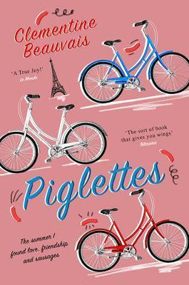
Talking about Piglettes

Social media
Have you heard of anything like the ‘Pig Pageant’ in real life?
How do we decide when something on social media stops feeling like a joke and starts being hurtful?
Do you think it’s harder being a teenager now than before social media appeared?
How do the three girls play with social media?

Body Image, Weight and Food
What did you think of the girls’ relation to their bodies?
What did you think of their relation to food and to cooking?
Kader, the girls and the old lady have all had tough relations to their bodies. What do they have in common? How do they help each other?

Family
What do you think of Philippe Dumont? Why did it take Mireille so long to recognise he’s not actually that bad?
Why is Mireille always arguing with her mother?
Does it matter that Klaus is her biological father? Should she have told him? What would have happened if she had?
What do you think of Hakima’s and Astrid’s families?

History and Society
What do wars do to people, to their bodies and minds? Are wars of the past different to wars today?
Why is Mireille so wary of being called a feminist?
What did you think of the journalists in the story? Why are the media so interested in the three girls’ journey?

Humour
Does laughing always make everything better?
Mireille says she can’t win the Nobel Prize because she can’t write serious texts. Are funny books less important than serious books?
Can a book be funny and serious at the same time?
Where’s the limit between being funny and being sarcastic or cynical?

The three girls
Which of the girls did you feel closest to? Why?
What do you think each of them gained on their journey?
What do you think Kader thinks of Mireille?

The book
Who do you think would enjoy this book and why?
Do you think boys would enjoy the book? Do you think they’d pick it up on their own? Why/ why not?
What would you say to convince someone to read it?
Does it matter to you that the book was not originally written in English? What do you think of the fact that it was translated by the author?

